**CHAPTER FOUR**

**IMPLEMENTATION AND TESTING/RESULTS AND DISCUSSION**

**4.1 Implementation**

The implementation of the Student Disciplinary Committee (SDC) Application contains several key aspects, including the design of screens for the mobile application, the use of open-source tools, implementing the mobile app and hosting and tracking of changes to the codebase using GitHub.

**4.1.1 Design**

The design of the mobile app screens was a critical aspect of the SDC Application development. Using Figma, a collaborative design tool, allowed for the creation of intuitive and user-friendly interfaces to be used in managing SDC cases. The design focused on ease of use, with clear navigation and a visually appealing layout. Screens were designed to allow users to create new cases, add case offenders, specify case types, view case details, and communicate what a case is about using clear descriptions. The below are some of the screenshots.

**Figure 1**

*Logo design*



**Figure 2**

*Splash screen and the login screen design*

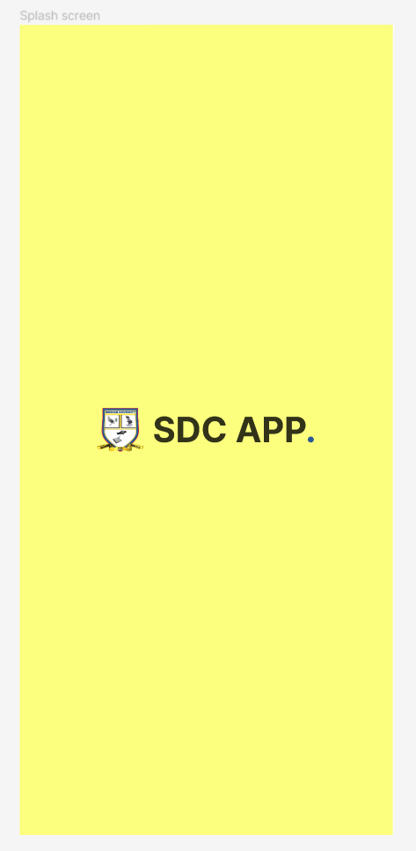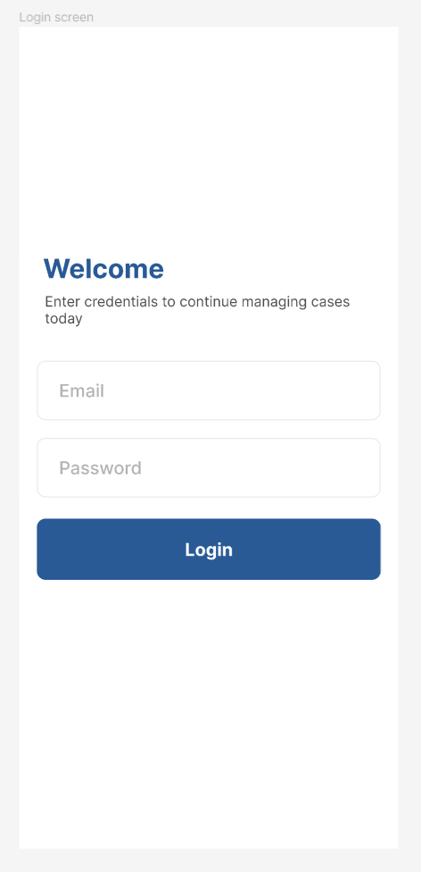

**Figure 3**

*The home screen design and a particular case screen design*

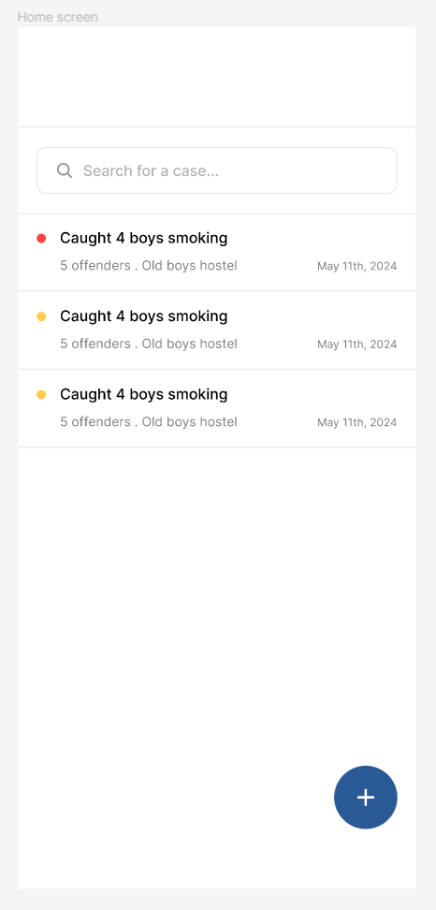

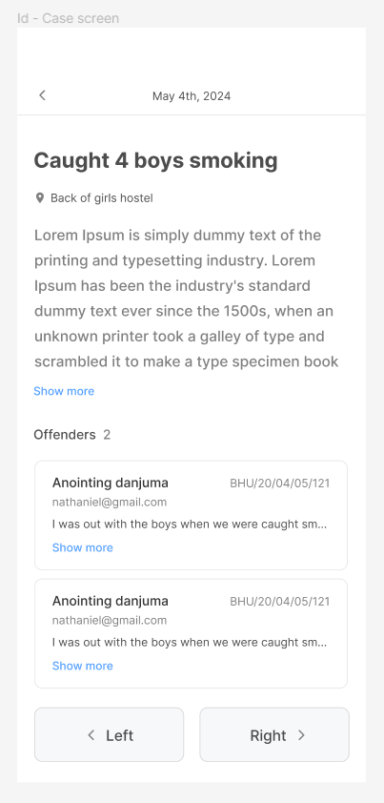

**Figure 4**

*The case form design and an offenders modal design*

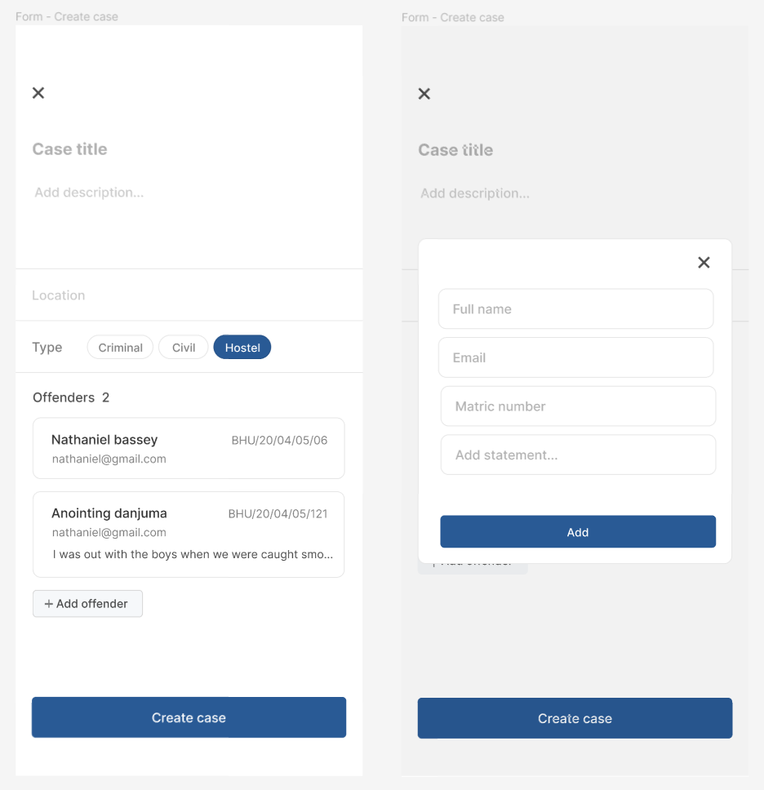

**4.1.2 Tools**

Several open-source tools were instrumental in building the SDC Application:

**DrizzleORM:** Used for managing the application's database queries, providing a simple, lightweight and efficient way to handle interactions. And it’s also type safe, which makes it that much indispensable.

**TursoDB:** Employed as a serverless SQLite for production, offering a lightweight and scalable database solution.

**Zustand & React Query:** Used for managing the application's state and handling data fetching, providing a robust and efficient way to manage data (Very important).

**React Native & Expo SDK 51.0:** Utilized for building the mobile app, allowing for the development of cross-platform applications with a single codebase.

**Bun, Next API Routes & Hono:** These tools were used to build and run the backend code on the edge using the vercel platform, enabling faster performance and improved user experience.

**Figure 5**

*The backend deployed on vercel*

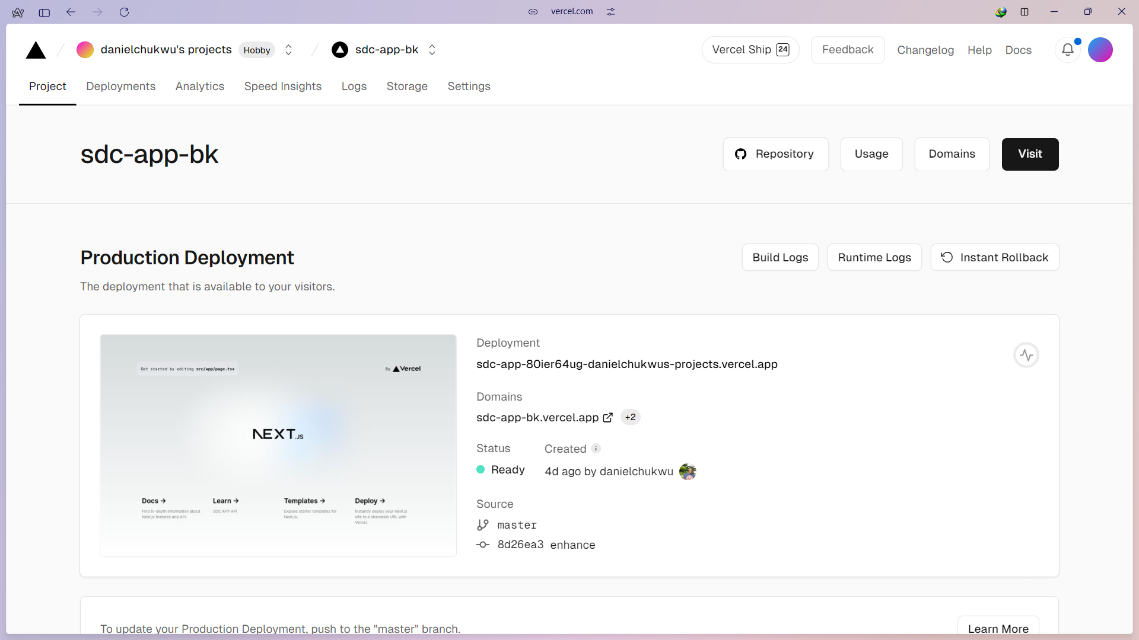

**4.1.3 GitHub Repository Codebase Screenshots**

The backend and frontend codebases for the SDC Application were hosted in separate GitHub repositories. The backend repository contains the server-side code, including API endpoints and database interactions, while the frontend repository contains the code for the mobile app interface.

**Figure 6**

*The mobile interface github repository*

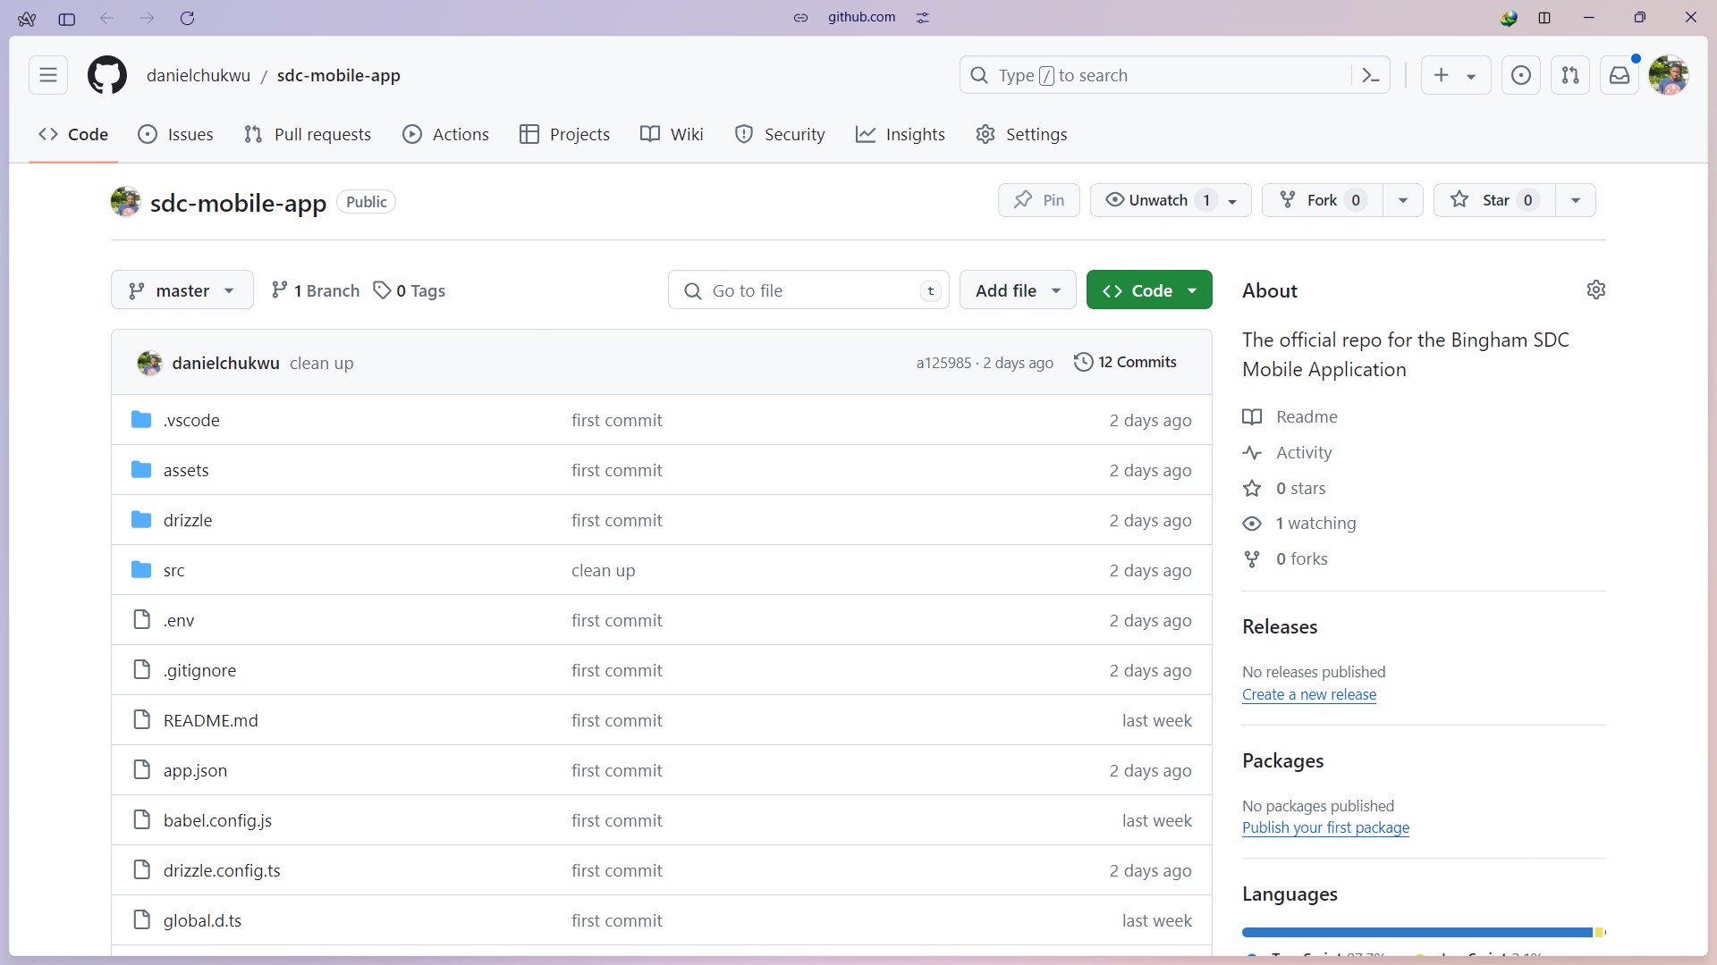

**Figure 7**

*The backend github repository*

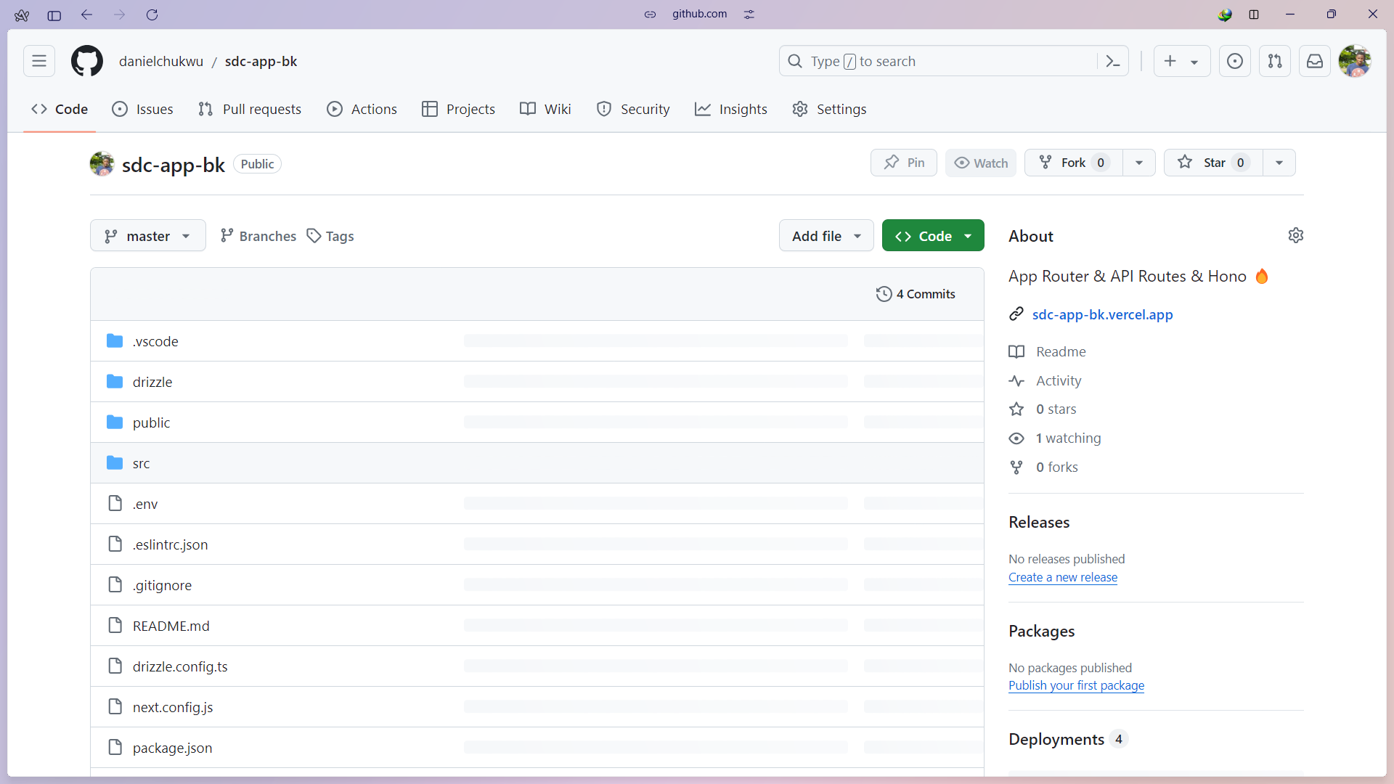

**4.1.4 Database Implementation**

The database used for the Student disciplinary committee application (SDC) is Turso, which provides an SQLite for Production service, it’s also a serverless solution that offers scalability and reliability for data storage. Turso SQLite for Production provides a CLI tool that enables developers to develop locally and easily switch to the hosted database in production.

**Figure 8**

*SDC application turso database*

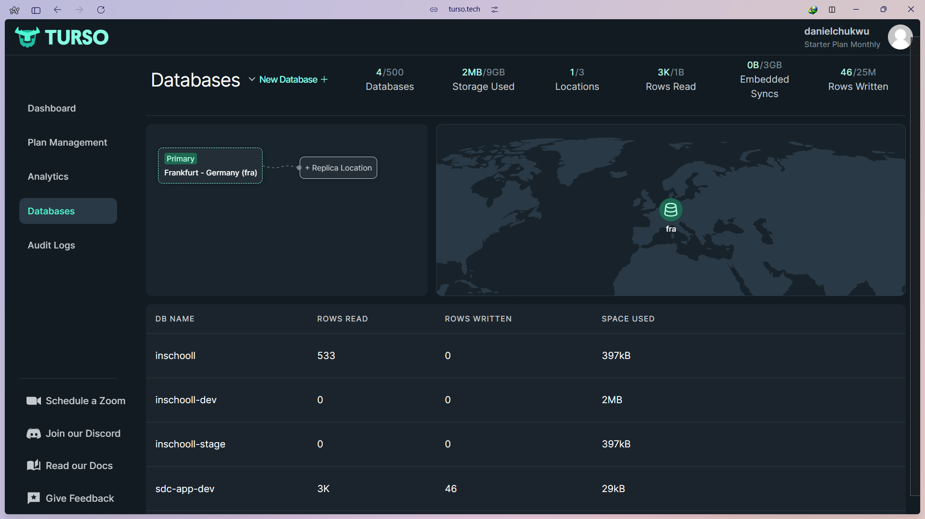

**Figure 9**

*Raw SQL JOIN query*

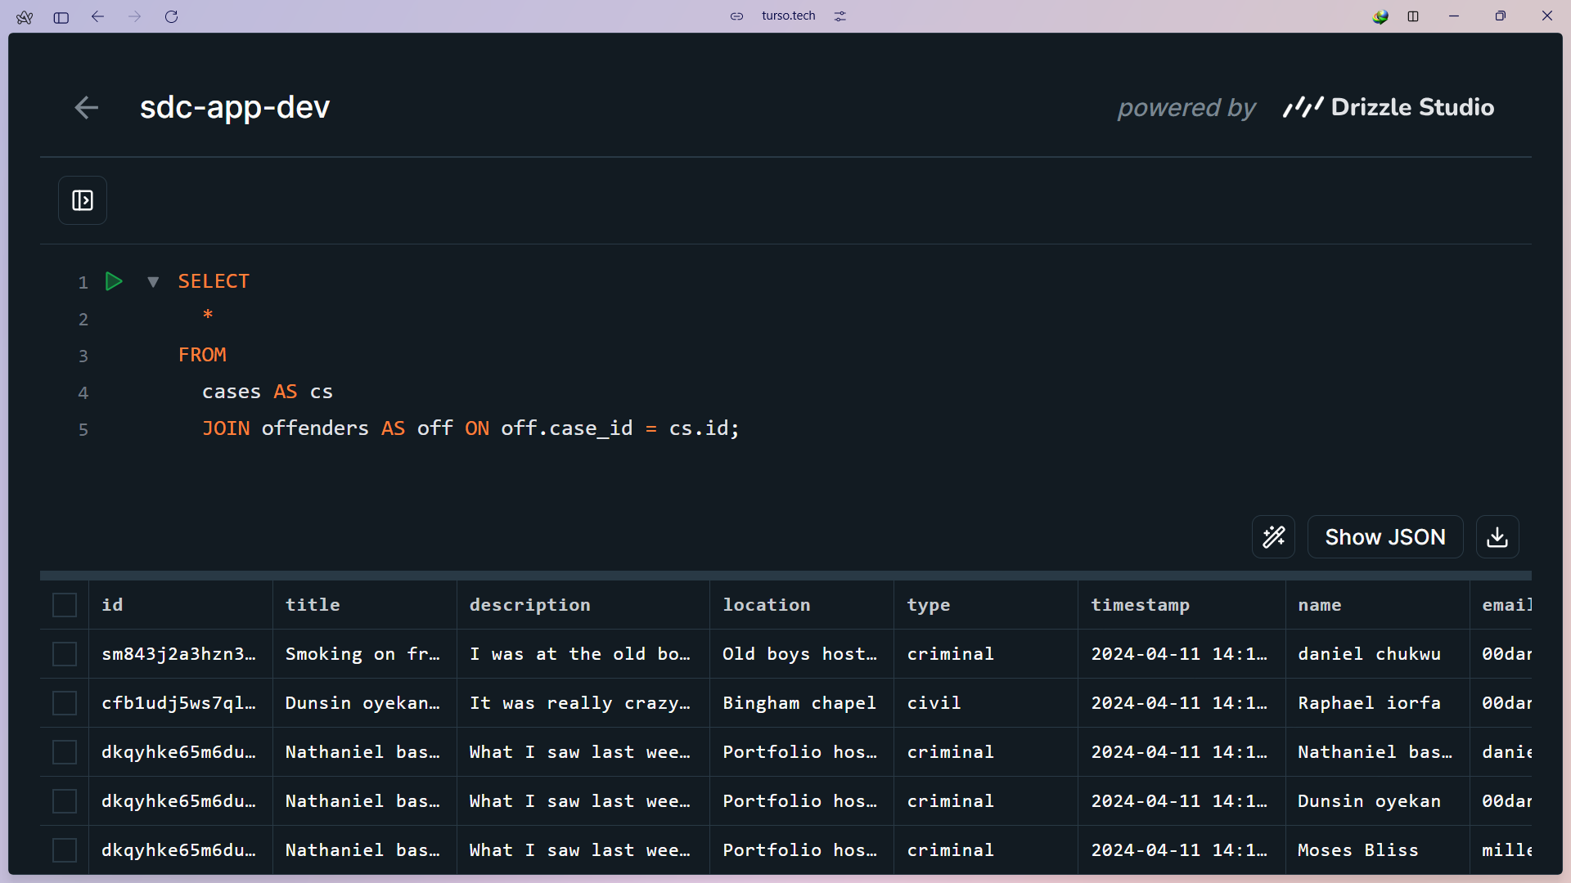

**Figure 10**

*Offenders’ database table*

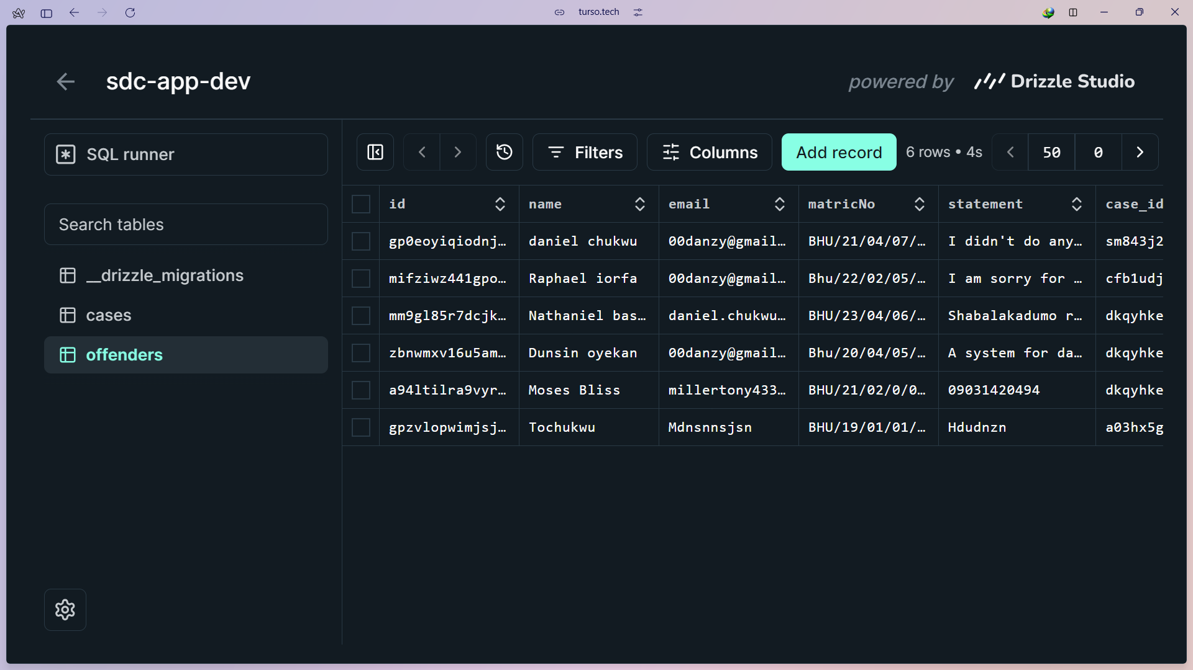

**4.1.5 Final product**

The below figures show the result of the development process so far.

**Figure 11**

*Mobile app screens*

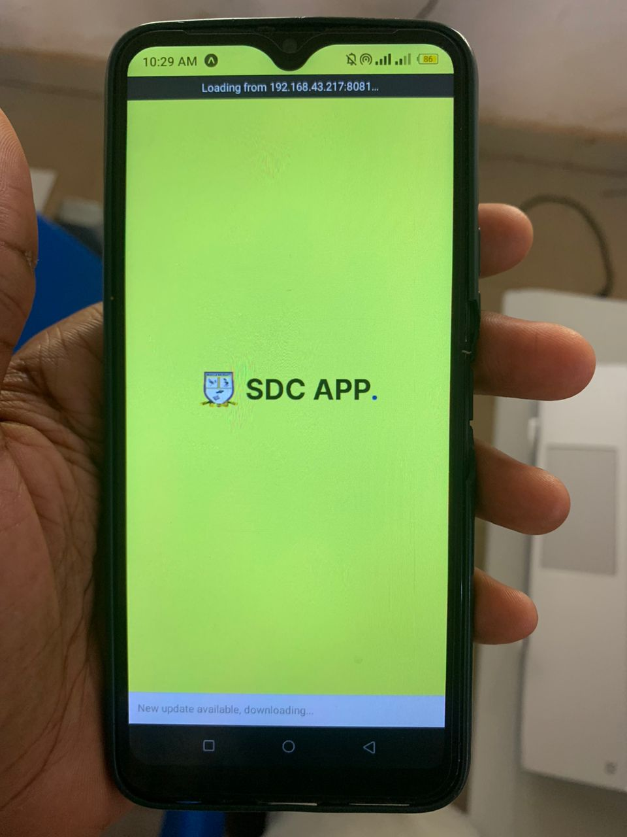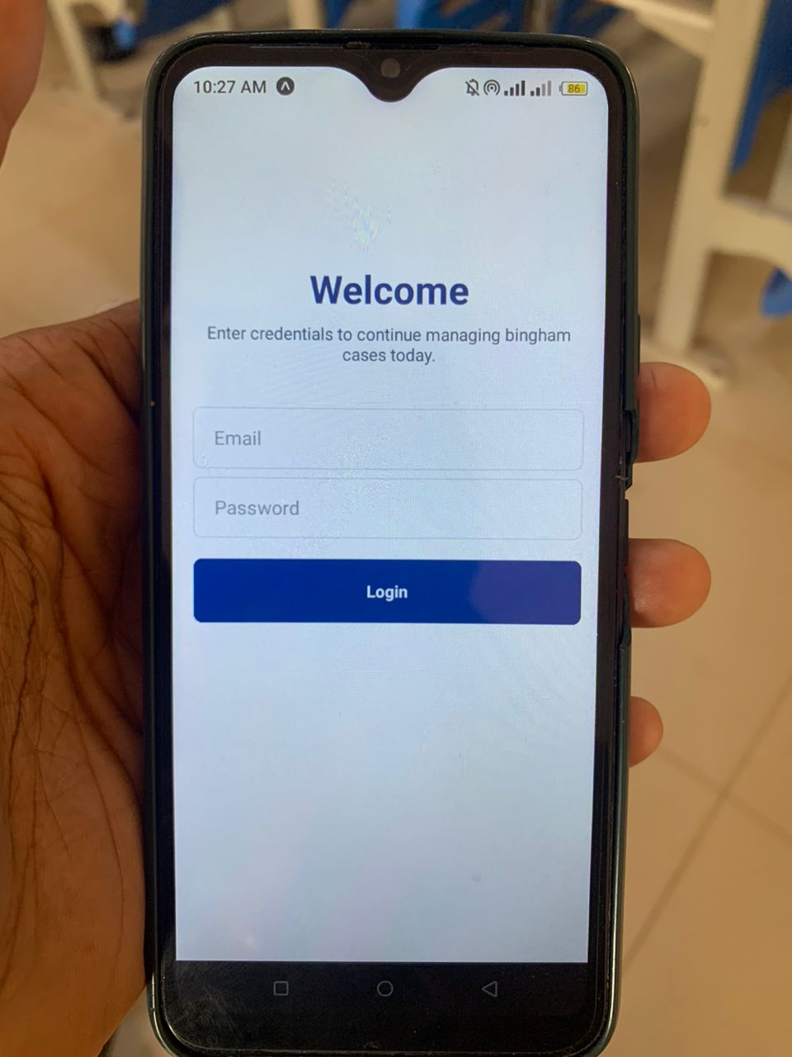

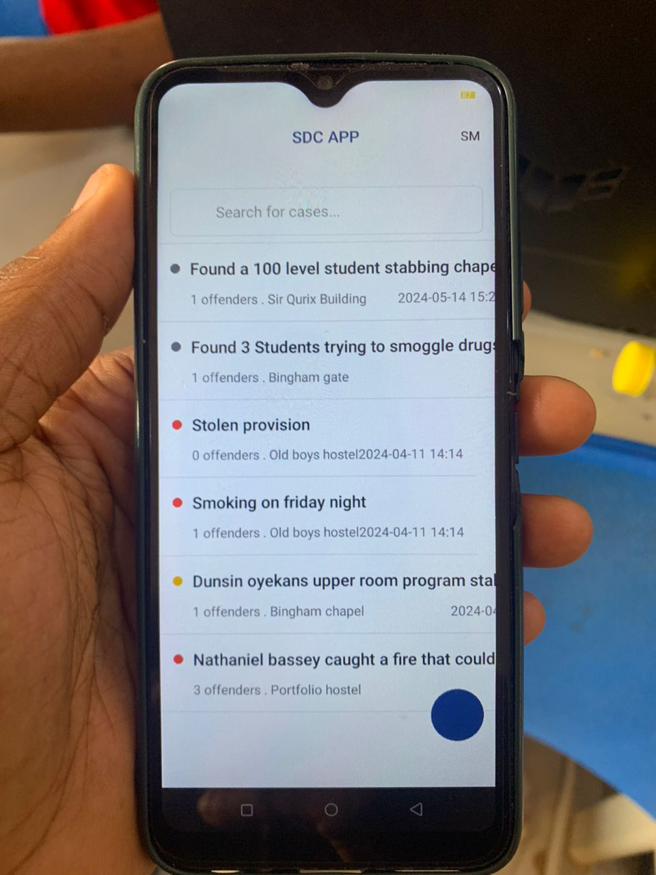

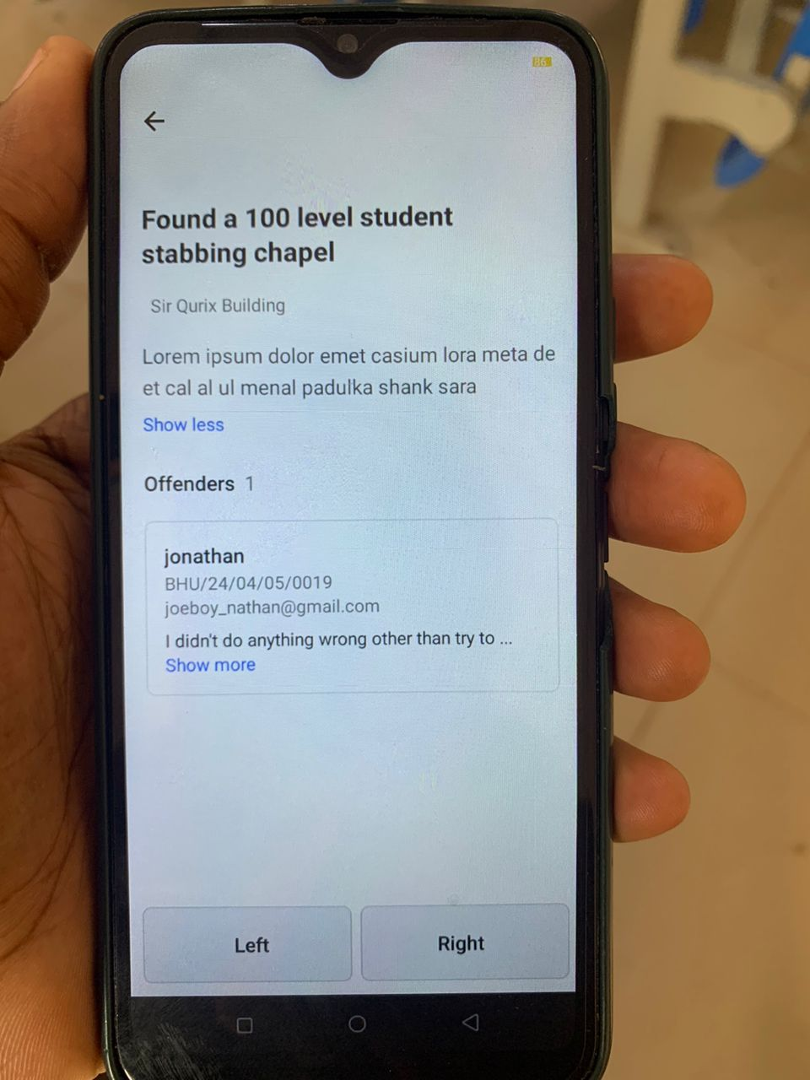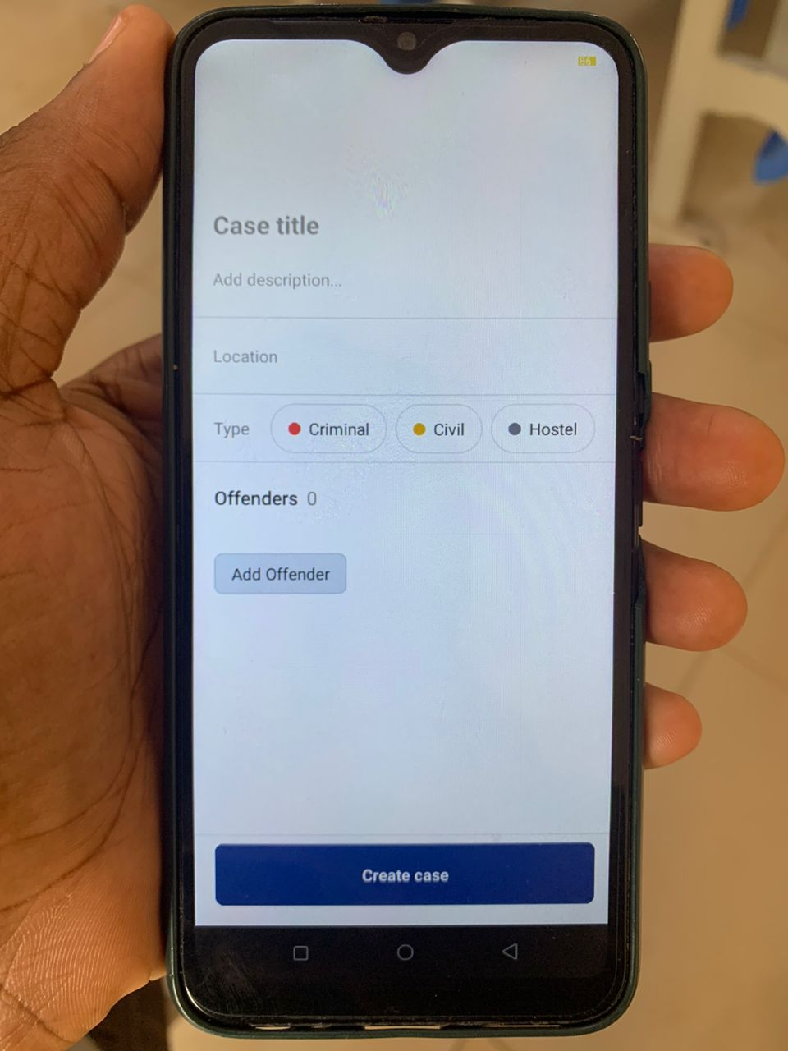

**4.2 Testing**

The testing of the SDC Application was carried out using the following libraries:

1. **jest:** Jest is an amazing, robust, industry-standard JavaScript Testing Framework used by some of the biggest tech companies in the world. It works with projects using: Babel, TypeScript, Node, React, and more. Hence making it a no brainer for the development of the SDC Application.
2. **react-test-renderer:** This package provides an experimental React renderer that can be used to render React components into pure JavaScript objects, without depending on the DOM or a native mobile environment in our case. Which is extremely important.

By using Jest and react-test-renderer, the testing process for the SDC Application is streamlined, making it possible to write more comprehensive tests for the app's components and functionalities.

**4.2.1 Unit Testing**

Jest and react-test-renderer libraries were used to unit test all the application components and utility functions. The screenshots below show some of these tests.

**Figure 11**

*Test files*

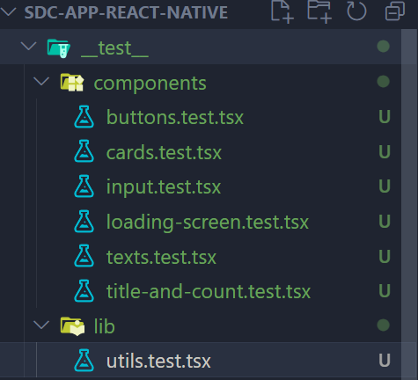

**Figure 12**

*Unit test code for a card component*

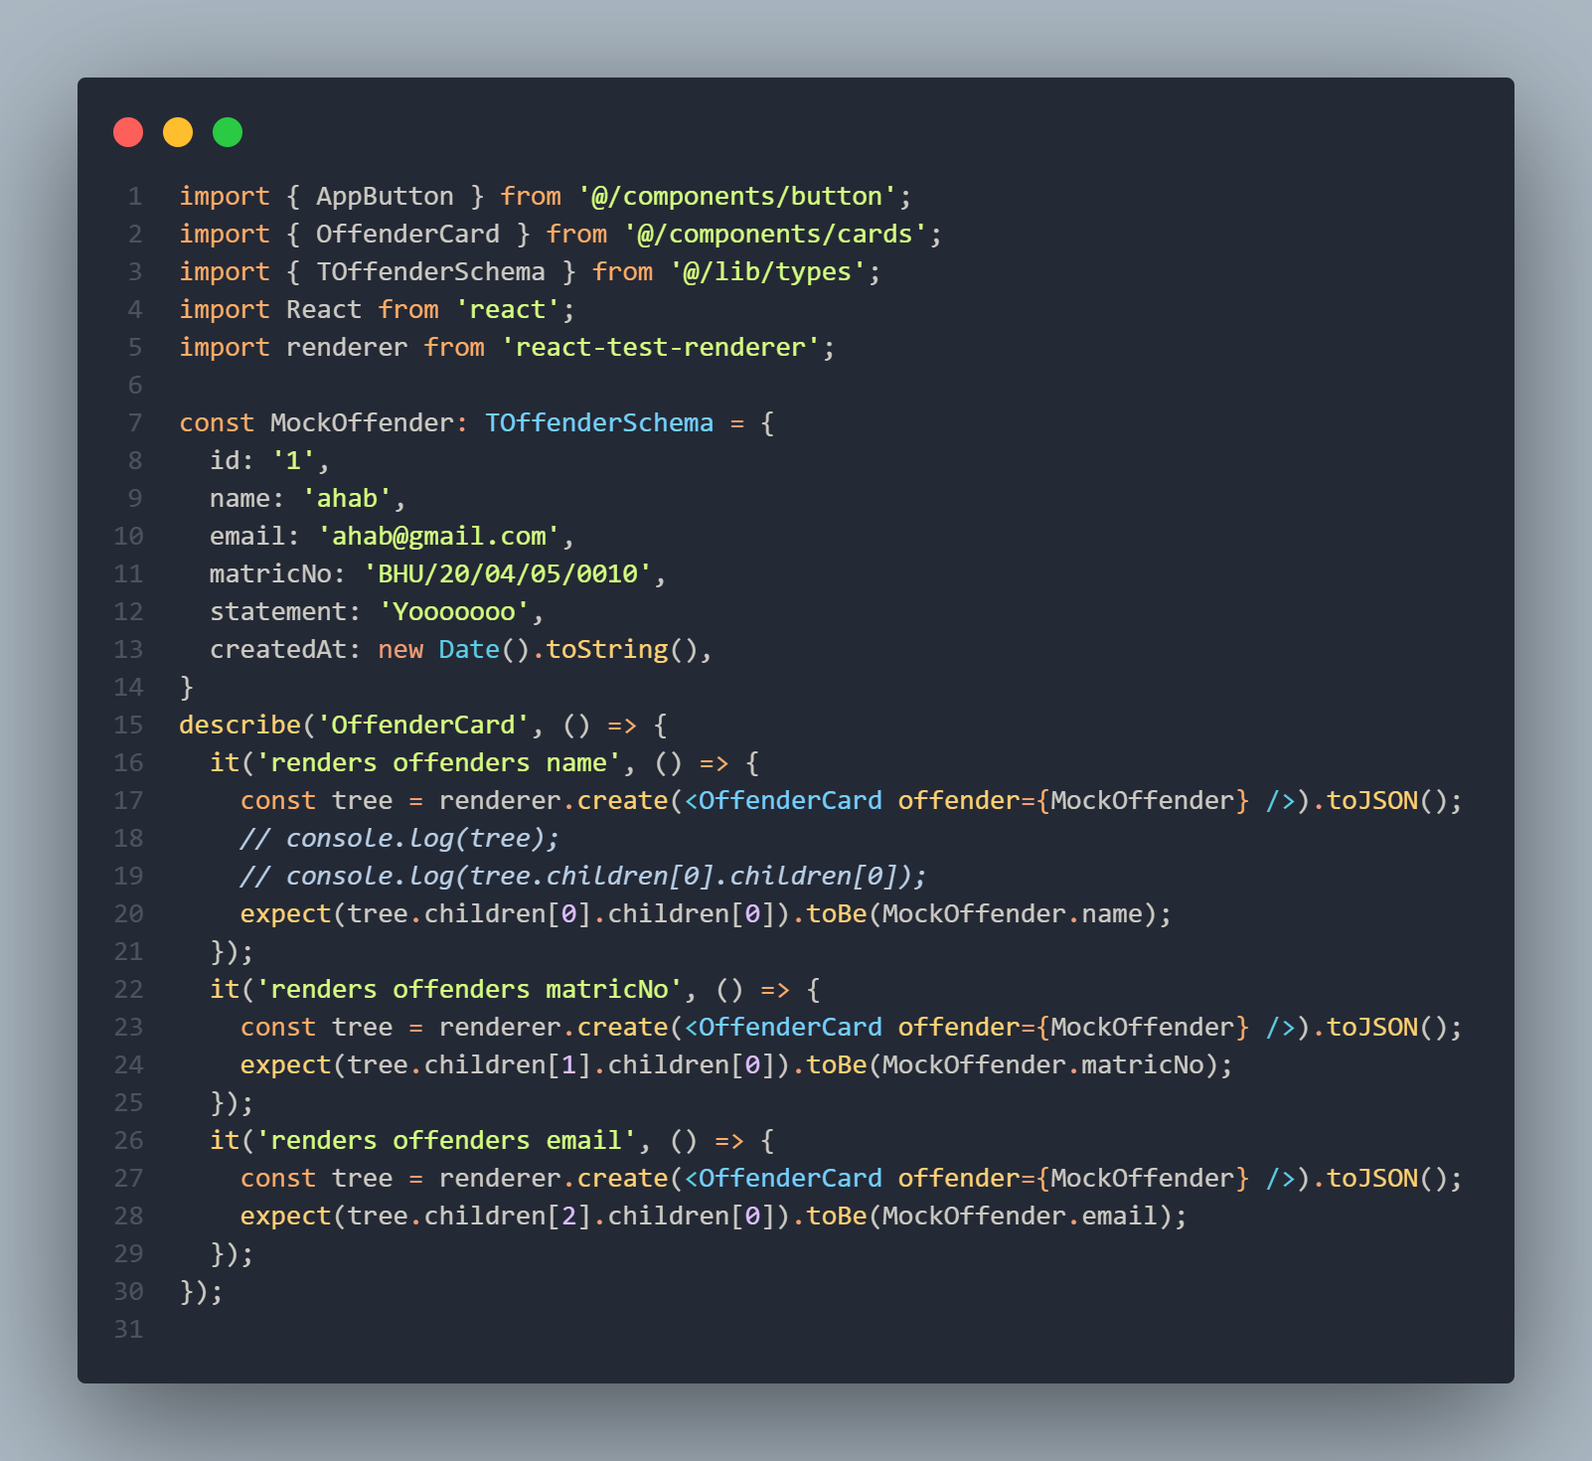

**Figure 13**

*Executed test results*

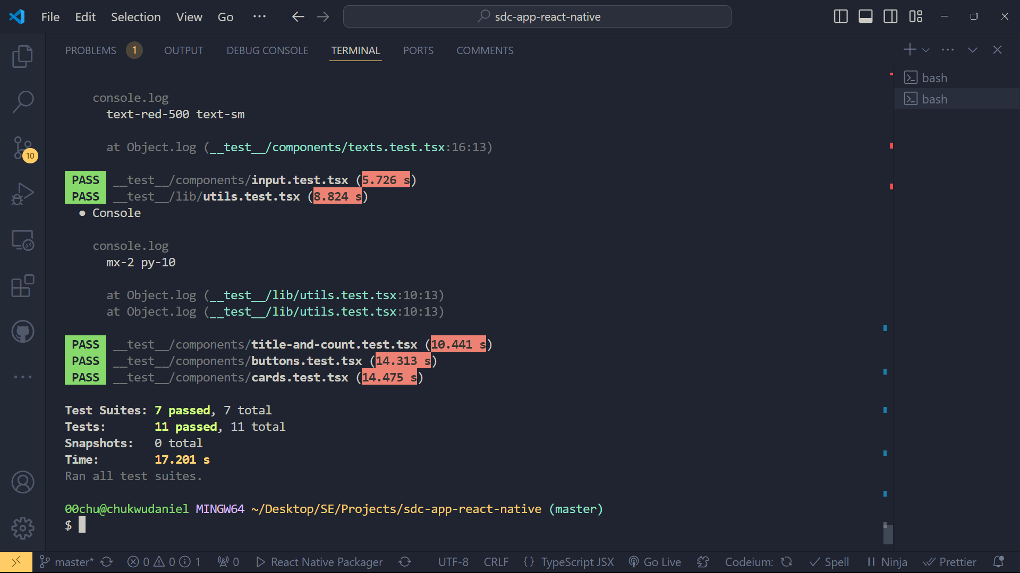

**CHAPTER FIVE**

**SUMMARY, CONCLUSION AND RECOMMENDATION**

**5.1 Summary**

This project aimed to develop a Student Disciplinary Committee (SDC) Application to digitize and streamline the management of disciplinary cases in universities. Through a multifaceted research approach involving user interviews, case studies, and observations, key insights were gathered to inform the application's design and functionality. The project employed the Agile methodology to ensure flexibility and continuous stakeholder feedback.

**5.1.1 Major Findings:**

**i. Design and Development:**

The mobile app screens were designed to provide an intuitive interface for managing disciplinary cases.

The project leveraged various open-source tools including DrizzleORM, TursoDB, React Query, React Native & Expo SDK 51.0, Bun, Next API Routes, and Hono.

The backend and frontend codebases were maintained in separate GitHub repositories to facilitate organized and efficient development.

**Database Implementation:**

TursoDB was used as the database solution, providing a serverless SQLite environment suitable for production. The use of Turso's CLI tool enabled seamless switching between local and hosted development environments.

**Testing:**

Jest and react-test-renderer were utilized to ensure the application's reliability and robustness. These tools facilitated thorough testing of both individual components and the overall system without depending on the DOM or native mobile environments.

**Challenges Encountered:**

Integrating diverse open-source tools required significant coordination and compatibility checks.

Ensuring data security and system scalability presented ongoing technical challenges.

Gathering comprehensive user feedback required meticulous planning and execution.

**5.2 Conclusion**

The SDC Application project has demonstrated that technology can significantly improve the management of disciplinary cases in educational institutions. The use of modern software development tools and methodologies allowed for the creation of a robust and user-friendly application. The project's success can be attributed to the thorough research, iterative development process, and continuous stakeholder engagement. The findings suggest that the digitalization of disciplinary processes enhances transparency, communication, and efficiency, ultimately benefiting both administrators and students.

**5.3 Recommendation**

Based on the findings of the study, the following recommendations are proposed:

**Wider Implementation:** Universities should consider adopting similar digital solutions to streamline their disciplinary processes. The SDC Application can serve as a model for other institutions seeking to enhance their case management systems.

**Continuous Improvement:** The application should be continuously improved based on user feedback and evolving needs. Regular updates and maintenance will ensure the application remains effective and secure.

**Training and Support:** Comprehensive training programs should be provided to all users of the application, including SDC members. Ongoing technical support will help users fully leverage the application's capabilities.

**Further Research:** Future research should explore the long-term impact of digital disciplinary systems on institutional culture and student behavior. Additionally, the integration of advanced features such as AI-driven analytics and automated reporting could be investigated.